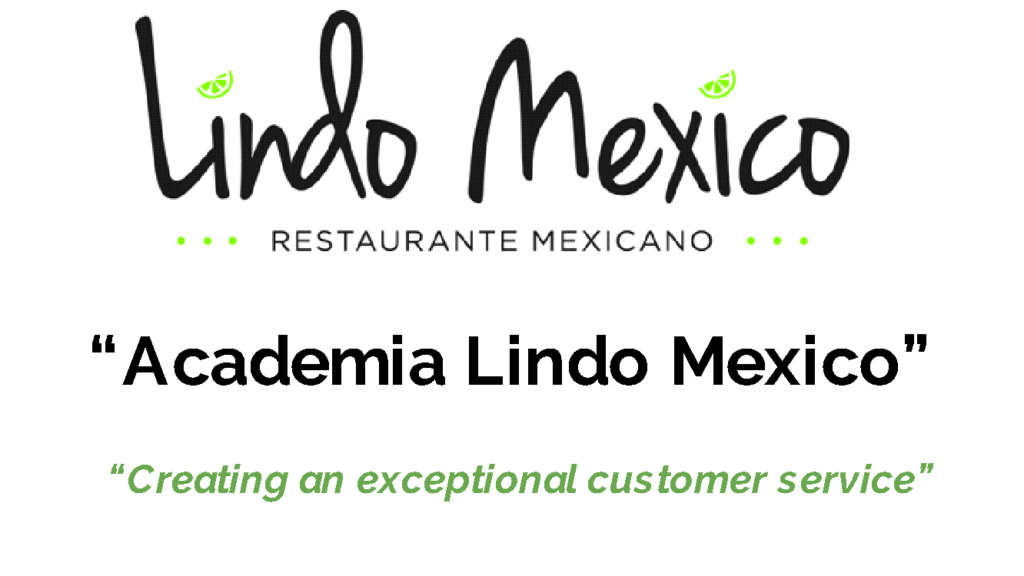

Session 2 “The organization’s mission and strategy”

- What is Lindo Mexico’s Vision? Lindo Mexico Restaurant is truly an original place where we provide authentic flavors of fresh Mexican Food. We create unique margaritas and other signature beverages. We hold community events and will entertain our guests with live music that brings happiness to the whole family. We are truly an original. We exceed our customer's expectation in every visit. We continue to bring a legacy of happiness and will for generations.
- What is Lindo Mexico’s Mission? We exist to provide an exceptional experience to everyone. We accomplish this through our high quality ingredients, unique beverage creations, live music, and our commitment to host events and support our community. Our foundation is built on respect to create a positive culture that offers growth for our employees and to develop their skills to better serve themselves as well as our community
Creating The Strategy
- Biggest Strengths: What core competencies are you (or do you need to) be good at to meet your core objectives?
  - Food
  - Service
  - Community events
  - Team work
  - Margaritas
  - Innovators
  - Management
  - Leaders in our Industry

- Biggest Weaknesses?

- Overall Outcomes for Your Business:

- Resources Needed to Achieve Objectives:

- Why Does an organization Exist?

- How are we directly benefiting from been part of an organization?

- What is our role in the vision and mission of the organization?

