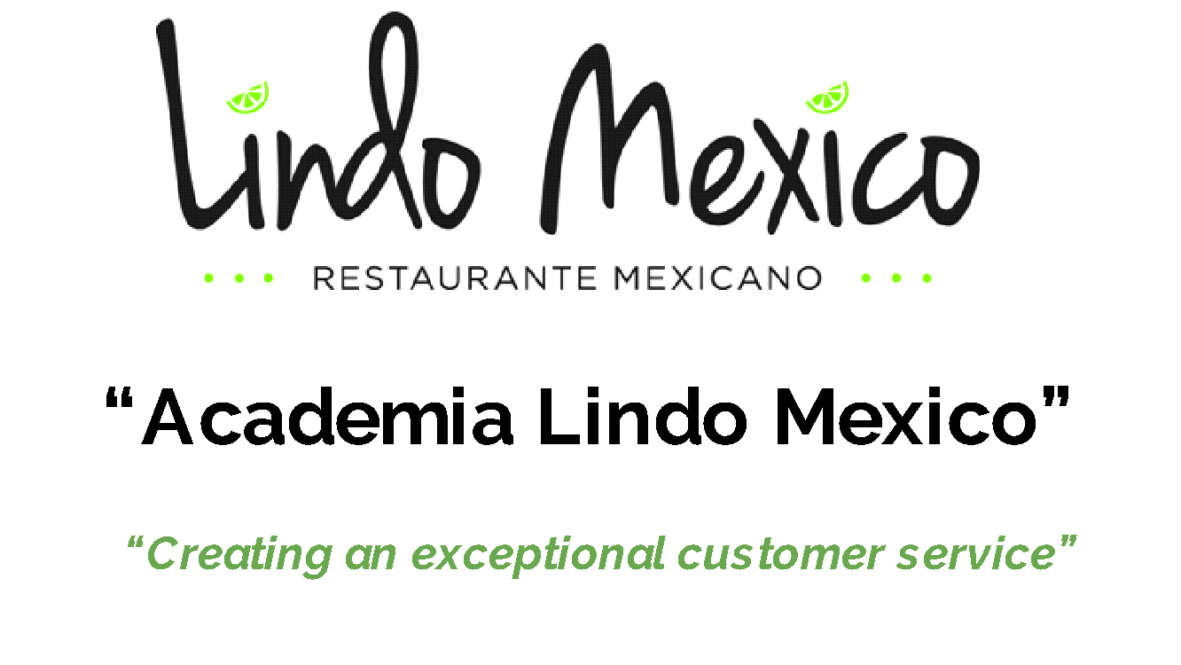
Session 3 “Effortless Persuasion. Increase sales abilities”

- What is a sale? “A sale is a financial exchange of a product or service for the satisfaction of the buyer and seller”
  - Why do we buy a service or product?

- Uncovering the client's needs and wants.
  - People buy with feelings.
  - Before you go to a table ask yourself….why am i doing here?
  - Each customers is unique...treat them uniquely.
  - Role Playing: Kathy did not say her name
        - Why are you here today?
        - Have you been here today?
        - Be Genuine when you ask how are you today?
        - Would you like to start with an appetizer?

- People buy with emotion, not with logic.
  - When customer ask what would you recommend...ask them more specific questions like, do you have a preference in meats, do you like spicy food….
Offer them the drink menu? What appetizer can i start you with?
Assume the sale (appetizers),
Ask them if they would like us to sing happy birthday to them?
If I am a customer, how would I like to be treated?.
Make the customer feel special.

- Use body language to communicate with certainty. (Role Playing)
  - Body, Facial expressions, eye contact 65%
  - Tone of voice 15%
  - The words we use 7%
  - Be sensitive, do not judge, do not take their actions personally.
- Up sale- cross sale and new sales strategies (The avocado Story) What is your avocado?
  - Use positive words when selling

- Know Your Product! (Role Playing)
- Removing subconscious patterns and beliefs that stop you from selling!

