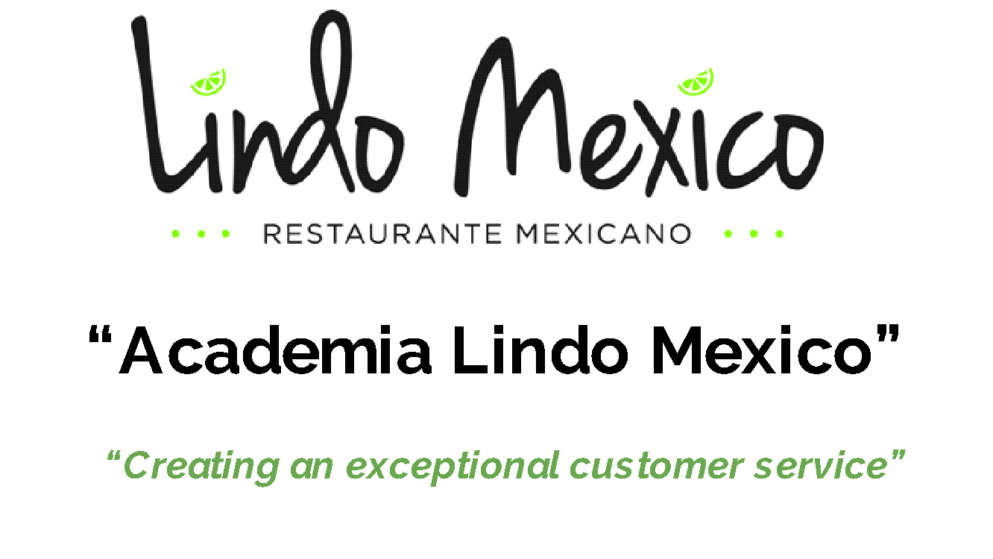
Session 1 “The Vision Multiplier”

Welcome Lindo Mexico Team
Congratulations for being here… For your commitment to make an impact, for your commitment in becoming who you were meant to be… You are valuable not just for this company, but to the world.
This program will help you gain clarity about your business identity, it will help you understand how you can serve the world with your God-given talents, you will eliminate beliefs and stories that have stopped you from achieving your maximum potential!
“It’s not what happens throughout our life that matters, what matters is how we react to it”
- Commitment: Be present in Mind-Body-Spirit
- Commit to being at your highest level of energy
- Discover your corporate identity in order to serve the world
- My Vision:
- (Who I will become)

My purpose:
My identity:

Code of conduct:

My values and rules:

What I Love:

What I hate:

What drives me:

What i’m committed to:

Top One year results:
(Physical body/health- Emotions & Meanings- Relationships- Time- Work & career- Finances- Contribution & celebration)

Use the SMART outcome setting
Creating S.M.A.R.T. Goals
Specific Measurable Attainable Realistic Timely
- Physical body/health

- Emotions & Meanings

- Time- Work & career

- Work & career- Finances

- Contribution & celebration

- Family

- Spiritual

