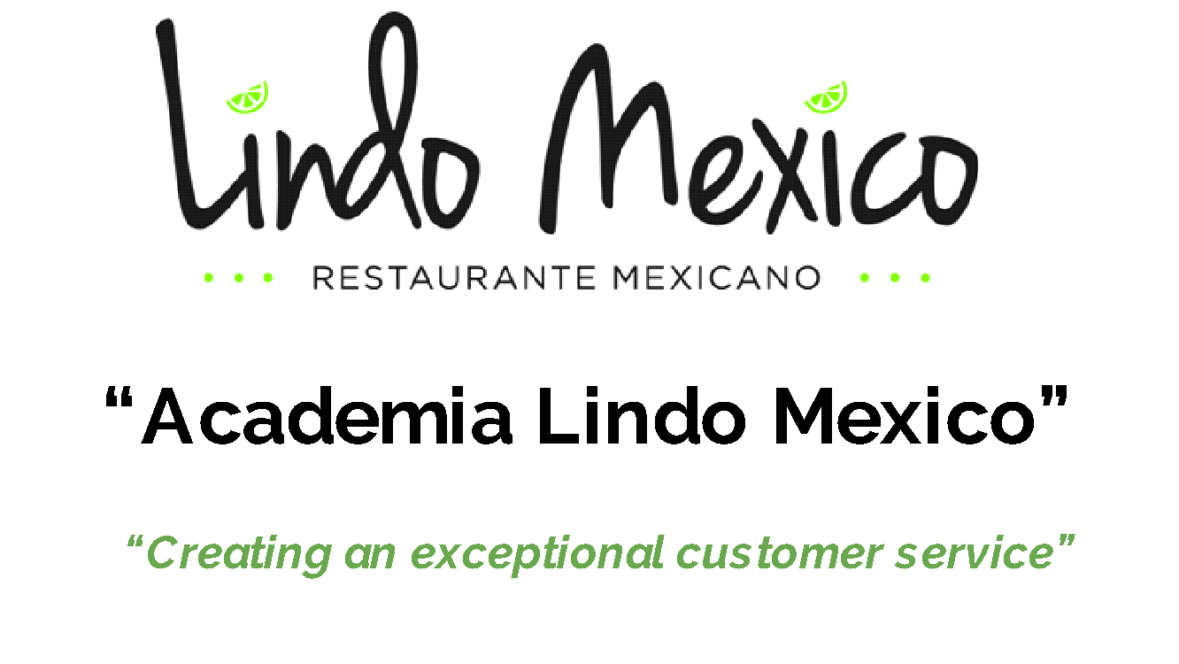
Session 12 “How to propose improvement ideas”
- HAVE CLEAR GOALS AND EXPECTATIONS TO YOUR EMPLOYEES
- REWARD AND ENCOURAGE OPEN COMMUNICATION
- BUILD SOCIAL MEDIA ENGAGEMENT
- ENCOURAGE INNOVATION
- CREATE A STRONG TEAM ENVIRONMENT
- CREATE NON-WORKING ACTIVITIES TO FOSTER RELATIONSHIP
- FEEDBACK - OFFER OPPORTUNITY TO SHARE OPINIONS AND FIND SOLUTIONS
- PROVIDE TO THE EMPLOYEES IN THEIR WORK AND GROWTH
- SHARE AND COLLABORATE ON PROBLEM-SOLVING
- DELEGATION AND CREATE INCENTIVES
- CELEBRATE ACHIEVEMENTS
- HAVE ACCOUNTABILITY- DO FOLLOW UP- MANAGE BUT AVOID MICROMANAGING
- ENCOURAGE- MOTIVATE- REWARD AND RECOGNIZE

