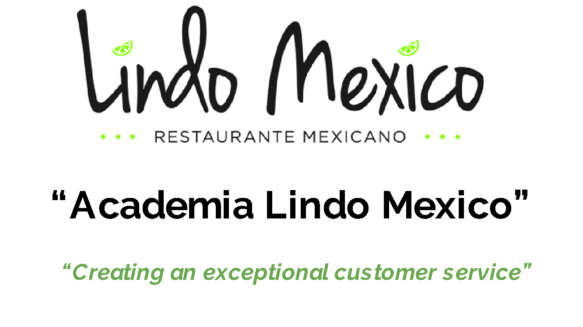
Session 9 “How to present a professional appearance and attitude”

- Personal grooming

- Proper Language
  - Read Books to improve your language and expand your vocabulary
  - Be Polite
  - Do not Judge
  - Do not use slang
  - Use Sir. Mam, ladies (Senor, Senora, Joven)
  - Do not use profanity
  - Do not use slang
  - Use common words that people can understand
  - Coach new employees to use proper language
  - Do not talk bad about other people or Co-Worker
  - If you don’t say something nice, please don’t say anything at all.
  - Learn what to share and what not to share.

- Reviewing the Uniform Code from Lindo Mexico
  - Make pictures and put outside of office with uniform procedure

- What is acceptable and what is not
- The importance of representing Lindo Mexico & Consequences of not doing it

