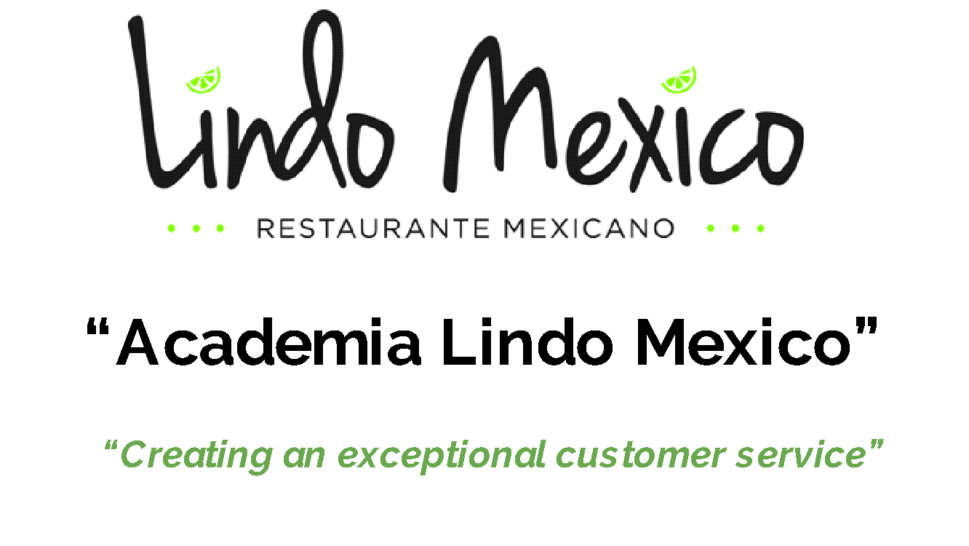

Session 5
“Phone Etiquette”

- Mastering Voice Tone. Body Posture And Clear Communication Over The Phone And In Person. (Enthusiastic. Sharp. With authority)

- The old and new sales strategies: (OLD SALES MODEL)
  - Build Relationship 10%.
  - Close The Sale 40%.
  - Share Your Qualifications and title 20%.
  - Deliver A Great Presentation 30%
. (NEW SALES MODEL)
a. Build Relationship 40%.
b.Confirm And Close The Sale 10%.
c.Deliver A Great Presentation 20 %.
d.Identify Needs 30%.
- Let them know they can decorate (no wall)
- Let them know they can bring a cake
- Use the right tone
- Offer drinks, desserts when they place the order (cross sale and upsell)

- The Difference between Goal-Oriented Approach VS Random Conversation (You <----------------> The Destination You Want To Take Others To.
  - What is the goal when you answer the phone. ?

- Ethical Close; NEVER pursue other’s to get something they don’t need or Want.
  - Offer once if they don’t want it the first time, don’t push

- 3 Tactics You Must Master In Order To Create An Effective Instant Connection: 1) Develop Instant Relationship

2) Ask Intelligent Questions.

3) Listen More That What You Talk. Find Out Exactly What The Client Needs and Wants.
- Keep The CLient Focused In The Sale, Don’t Get Off Track With The Conversations.

- Have Total Clarity Of WHY You Must Deliver Excellent Service. The WHY Is What moves You And Keeps you Focused.
  - Script for Lindo Mexico
    - Thank you for Calling Lindo Mexico, this is xxxxxxx, how may I help you today.?
    - Want to place an order: Have you order from us before?
    - Yes, may i please have your phone number to look you up in the system?
    - No. I will be happy to assist you, in order for me to enter the order in the system, may i please have your phone number starting with the area code?

- Have And Follow A Phone Script. Destroying Negative/Limiting Beliefs. Mention Other People’s Samples Of Buying Your Products.

- Acquire The Of Confident About The Following: Client Loves Lindo Mexico products. Clients Love And Trust You, The Team and The Business.

Script Sample:
Script for Lindo Mexico
    - Thank you for Calling Lindo Mexico, this is xxxxx, how may I help you today.?
    - Customer wants to place an order: “Have you order from us before?”
    - IF Yes: Say “may i please have your phone number starting with area code to look you up in the system?”
      - When you find the record, ask, for charlie? address them by their first name…..”What would you like to order today Charlie”?
    - IF No: Say “I will be happy to assist you, in order for me to enter YOUR ORDER in the system, may i please have your phone number and full name?…….., (you need to make sure you enter the full name)
    - What drink would you like to me add to your order today?
    - Would you like to add a dessert to your order?
    - Would you like mild or spicy salsa to go with your order?
    - Just to make sure i have your order correct, i am going to repeat it for you…….does that sound correct?
    - Great! Your total is $_______________, we will see you in about _________minutes.

- Raise your voice when you are giving a command
- When you don’t know what to say or what to do: Do the following: Can i put you on hold for a moment while i get someone to assist you?

